Visoka škola stukovnih studija za informacione i komunikacione tehnologije

***Aleksandar Janjic 331/16***

smer: Internet thenologije

modul: Web programiranje

predmet: Web programiranje 2

Dokumentacija za sajt:

***https://aleksandarjanjic331-16.netlify.com***

# Sadržaj :

# 1. Uvod :

**1.1 Korišćeni programski jezici**

**1.2 Opis funkcionalnosti**

**1.3 Template**

**1.4 Korišćeni CSS**

# 2. Organizacija :

**2.1 Organizaciona šema**

**2.2 Mapa sajta**

## 2.3 Slike stranice i opisi funkcionalnosti

**2.3.1 Index**

**2.3.2 characters**

**2.3.3 register**

**2.3.4 about**

**2.3.5 sezona1**

# 3. Kodovi :

## 3.1 HTML :

**3.1.1 Index.html**

**3.1.2 characters.html**

**3.1.3 register.html**

**3.1.4 about.html**

**3.1.5 sezona1.html**

## 3.2 CSS :

**3.2.1 index.css**

**3.2.2 characters.css**

**3.2.3 register.css**

**3.2.4 about.css**

**3.2.5 sezona1.css**

## 3.3 JavaScript / Jquery :

**3.3.1 index.js**

**3.3.2 indexjquery**

**3.3.3 main1.js**

**3.3.4 main.js**

**3.3.5 charactersjquery**

**3.3.6 register.js**

**3.3.7 about.js**

**3.3.8 sezona1.js**

# 1. Uvod

## 1.1 Korišćeni programski jezici :

Za izradu sajta korišćeni su sledeći jezici: HTML, CSS, JavaScript, XML, AJAX, JSON, JQuery i njegovi pluginovi.

## 1.2 Opis funkcionlanosti

Sajt ima sledece funkcionalnosti:

-Stilizovani RSS i SiteMap se nalazi na svakoj stranici. Pretraga sajta preko JavaScript-a, XML-a

-Sadržaj stranica sa artiklima popunjen elementima XML fajla

-Slajder koji automatski menja slike

-Scroll to top

## 1.3 Template

*(html kodovi za header I footer na svakoj stranici su isti)*

<body>

<div id="okvir">

<div id="header">

<div id="header_gore">

<div id="header_logo">

</div>

</div>

<div id="header_meni">

</div>

</div>

<div id="footer">

<div id="footer_levo">

</div>

<div id="footer_desno">

</div>

</div>

</div>

</body>





### 1.3.1 Index.html

<div class="slajder">

<div class="mojslajder">

<div class="numbertext">1 / 3</div>

</div>

<div class="mojslajder">

<div class="numbertext">2 / 3</div>

</div>

<div class="mojslajder">

<div class="numbertext">3 / 3</div>

</div>

</div>

<div id="telo">

<div class="telo_glavni">

</div>

<div class="telo_glavni">

</div>

<div class="telo_glavni">

</div>

<div class="telo_glavni">

</div>

</div>

<div id="dno">

<div class="dno_glavni">

</div>

<div class="dno_glavni">

</div>

<div class="dno_glavni">

</div>

<div class="dno_glavni">

</div>

<div class="dno_glavni">

</div>

</div>





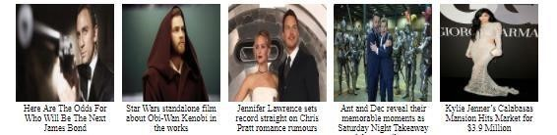

### 1.3.2 characters.html

<div id="galerija">

<div id="izbor">

<div id=”izborLevo”>

</div>

<div id=”izborSredina”>

</div>

<div id=”izborDesno”>

</div>

</div>

</div>

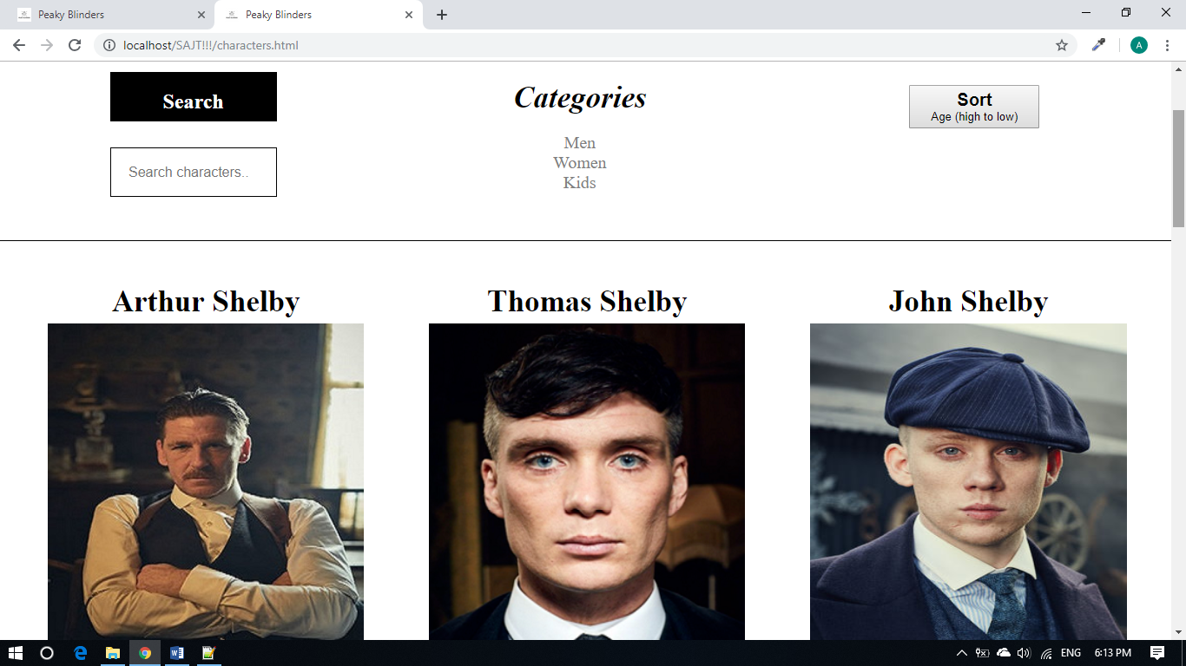

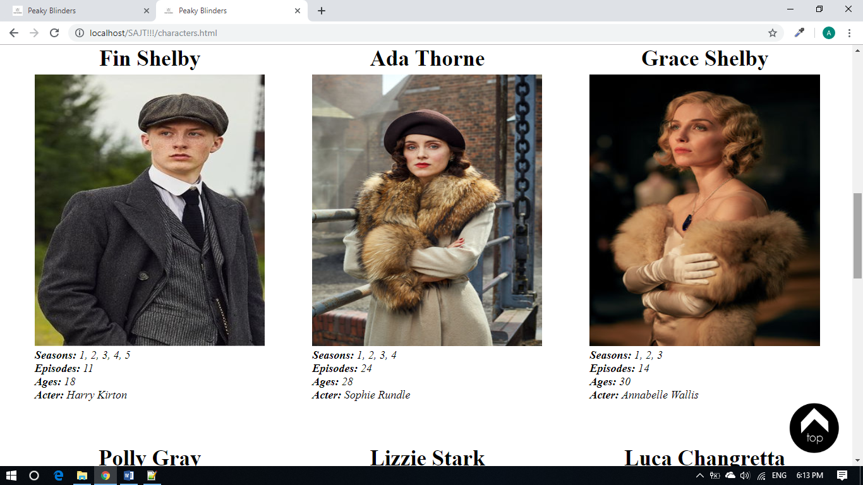

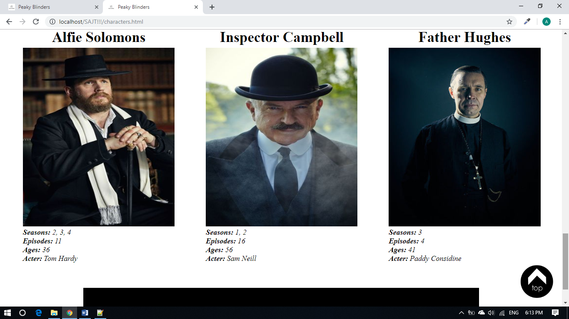

### 

### 1.3.3 register.html

<div class="centar">

<div id="forma">

</div>

<div id="ispis">

</div>

</div>



### 1.3.4 about.html

<div id="sadrzaj">

<div id="slika

</div>

<div id="ispis">

</div>

</div>

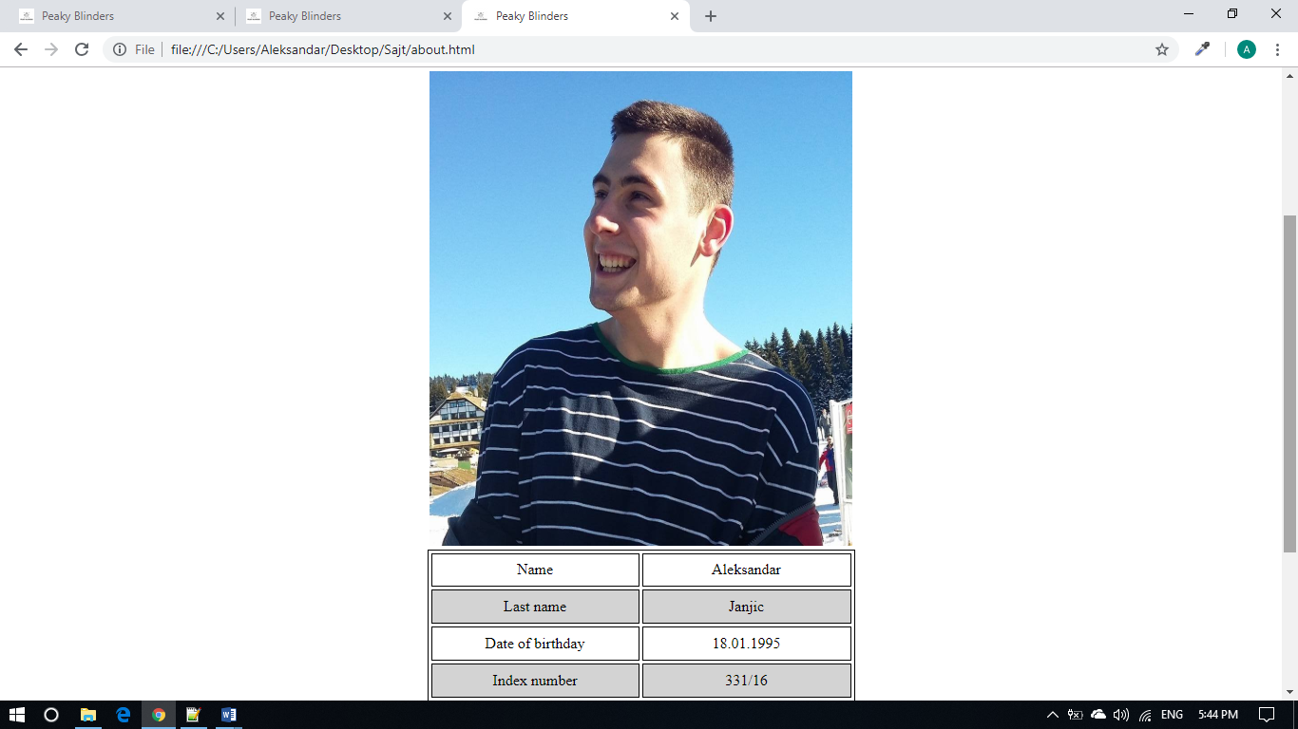

### 

### 1.3.5 sezona1.html

<div id="sadrzaj">

<div id="sadrzajlevo">

</div>

<div id="sadrzajdesno">

</div>

</div>



## 

## 1.4 Korišćeni CSS

*(I ovde su header I footer isit za svaku stranicu)*

*

{

margin:0px auto;

padding:0px;

} ul {

list-style:none;

} a

{

text-decoration:none;

}

#okvir

{

width:100%;

height:auto;

}

#header

{

height:160px;

width:100%;

}

#header_gore

{

width:100%;

height:100px; background:black;

}

#header_logo img

{

padding-left:250px;

}

#header_logo

{

background:black;

height:100px;

width:82%;

float:left; text-

align:center;

}

.hedergore

{

padding-top:40px; padding-

left:130px;

}

#header_meni ul

{

text-align:center;

}

#header_meni ul li

{

list-style:none;

display:inline-block; fontsize:18pt; padding:20px;

}

#header_meni a

{

color:#DADADA;

}

#lista1 ul li

{

display:block;

color: #000;

background-color: #fff

}

#header_meni

{

background:#000000;

width:100%; height:60px; text-align:center;

}

#footer

{

margin-top:40px;

display:flex; flex-wrap:wrap; width:950px; height:160px; background:black;

}

#footer_levo

{

width:80%; height:auto;

}

#footer_levo li

{

list-style:none; display:inlineblock; text-align:center; fontsize:18pt; padding-top:65px; padding-left:30px;

}

#footer_levo a

{

color:#DADADA;

}

#footer_desno

{

width:20%;

height:100px; margin-top:55px;

}

#footer_desno a

{

padding-left:10px;

}

### 

### 1.4.1 index.css

#header_meni ul

{

text-align:center;

}

#header_meni ul li

{

list-style:none;

display:inline-block; fontsize:18pt; padding:20px;

}

#header_meni a

{

color:#DADADA;

}

#lista1 ul li

{

display:block;

color: #000;

background-color: #fff

}

#header_meni

{

background:#000000;

width:100%; height:60px; text-align:center;

}

.btnSignIn

{

width:80px;

height:30px;

background:gray; border:none; color:#fff; height:auto; fontweight:bold; display:inlineblock;

padding:10px; border-

radius:5px;

}

#searchForm2

{

margin-top:50px; margin-

left:70px;

}

h3

{

font-size:12pt; textdecoration:underline;

}

h2

{

text-align:center;

}

.btnLogin

{

background-color: white;

border: none; color: gray;

padding: 15px 32px;

text-align: center; textdecoration: none; display: inline-block; border-radius: 5px; font-size: 18px; fontweight: 700; font-family:futura-pt,sans-serif;

}

.slajder

{

width:799px; position: relative; margintop:40px;

}

.mojslajder

{

display: none;

}

.numbertext

{

color: #f2f2f2; fontsize: 12px; padding: 8px

12px; position: absolute;

top: 0; }

#telo

{

margin-top:40px;

width:797px; border:1px solid black; height:1000px;

display:flex; flex-wrap:wrap;

}

.telo_glavni

{

width:300px;

height:405px; border-bottom:1px solid black; margin:50px 40px 40px 55px;

}

.telo_glavni p

{

padding-top:5px;

}

#dno

{

display:flex; flexwrap:wrap; margin-top:40px; margin-bottom:40px;

width:808px;

height:200px; text-align:center;

}

.dno_glavni

{

width:150px;

height:150px; margin-left:9px;

}

.dno_glavni p

{

font-size:10pt;

}

#scrollToTop

{

background:#white;

padding:10px;

position:fixed;

right:10px;

bottom:0px;

display:none;

}

.fa-angle-double-up

{

font-size:40px;

color:#fff;

}

### 

### 1.4.2 characters.css

#galerija

{

display: flex;

flex-wrap: wrap;

width:100%;

height:auto;

}

#izborLevo{

width:33%;

height:auto;

float:left;

}

.searchNaziv {

padding: 20px;

text-align:center;

border:1px solid black;

width:150px;

margin-top:50px;

margin-bottom:15px;

height:15px;

background-color:black;

color:white;

}

#search{

padding: 20px;

margin-left:127px;

border:1px solid black;

width:150px;

margin-top:15px;

margin-bottom:50px;

height:15px;

font-size:16px;

}

#izborSredina{

width:33%;

height:200px;

float:left;

}

.kategorije{

text-align:center;

margin-top:60px;

}

h3 {

font-size :35px;

}

#categories{

margin-top:20px;

text-align:center;

}

#categories li a{

color:gray;

font-size: 20px;

}

#izborDesno{

width:32%;

height:200px;

float:right;

}

#dropdownMenu{

width: 150px;

height:50px;

margin-top:65px;

margin-left:130px;

}

#glumci

{

width:100%;

}

.glumac

{

float:left;

width : 27%;

padding:20px;

margin-left:35px;

padding-top:50px;

}

.glumac img

{

width:100%;

padding-top:5px;

height:430px;

}

#izbor

{

height:auto;

border-bottom:1px solid black;

width: 100%;

}

### 

### 1.4.3 register.css

*(preuzeto sa lab vezbi uz male izmene)*

.centar

{

width:1280px;

margin:0px auto;

}

.sadrzaj

{

width:1000px;

height:300px; border:1px solid

#252525; margin:15px

auto;

}

.slicica

{

border-right:1px solid #252525;

float:left;

}

.slicica img

{

width:294px;

height:294px;

}

.opis

{

float:right; width:695px; padding:20px

0px;

}

.opis h2

{

text-transform:uppercase;

background:none;

color:#252525; letter-spacing:0px; font-weight:800;

}

.opis p

{

font-weight:bold;

padding:20px; margin:10px 0px;

}

.opis a

{

background:#0ba39c;

color:#fff;

display:inline-block; padding:20px; text-

align:center; texttransform:uppercase;

}

img.profil

{

width:563px;

height:353px; display:block; margin:20px auto;

}

#biografija

{

width:800px;

margin:20px auto; padding:30px;

}

#biografija p

{

line-height:25px; margin-

bottom:30px;

}

#navigacija ul

{

background:#252525;

padding:10px;

}

#navigacija ul li a

{

color:#fff;

}

.centar ol

{

width:800px;

margin:30px auto;

}

.centar ol li

{

text-align:left; paddingbottom:10px; font-size:18px;

}

#ispis

{

border:1px solid #0ba39c;

margin:20px auto;

width:800px; padding:10px 0px;

text-align:left;

display:none;

}

.centar ul

{

list-style-type:square !important;

}

.centar ul li

{

display:block;

}

#forma

{

margin:20px auto;

border:1px solid #252525;

width:800px;

padding:10px 0px; text-

align:left;

}

#forma table

{

margin:10px auto;

}

#forma table td

{

padding:5px 0px; text-align:left;

}

input[type="text"]

{

width:220px;

height:30px;

}

select

{

height:30px;

}

#taster

{

margin-top:10px;

padding:5px; background:black; border:none; color:white; width:100%; height:30px; font-weight:bold;

}

### 

### 

### 1.4.4 about.css

#sadrzaj

{

width:100%;

height:auto;

}

h3

{

text-align:center; font-

size:20pt; font-family:arial,helvetica;

}

h2

{

text-align:center;

}

table

|  |  |
| --- | --- |
| { |  |
|  | width:450px; |
|  | height:160px; |
|  | border:1px solid black; |
|  | border-collapse:separate; |
|  | border-spacing:3px; |
|  | margin-top:100px; |
| }  td  { |  |
|  | border:1px solid black; |
|  | text-align:center; |
| }  h1  { | width:100px; |
|  | text-align:center; |

padding-top:30px;

}

#slika

{

margin-top:40px; margin-bottom:-

100px; text-align:center;

}

#slika img

{

width:33%;

height:500px;

}

### 

### 1.4.5 sezone1.css

#sadrzaj

{

margin-top:80px;

display:flex; flex-wrap:wrap; width:100%; height:500px;

}

#sadrzajlevo

{

width:40%;

height:500px;

}

#sadrzajlevo img

{

width:100%;

height:100%;

}

#sadrzajdesno

{

width:40%;

height:500px;

}

h1

{

text-align:center; font-style:italic;

}

p

{

font-family:cursive;

}

#show

{

margin-top:50px; margin-

left:200px; background-color: black; border: none; color: white;

padding: 15px 32px;

text-align: center; text-decoration: none; display: inline-block; borderradius: 5px; font-size: 18px; fontweight: 700; font-family:futurapt,sans-serif;

}

# 

# 2. Organizacija

## 2.1 Mapa sajta

<?xml version="1.0" encoding="UTF-8" ?>

<urlset xmlns="http://www.sitemaps.org/schemas/sitemap/0.9">

<url>

<loc>http://PeakyBlinders1.eu.pn/index.html</loc>

<lastmod>2016-12-03</lastmod>

<changefreq>monthly</changefreq>

<priority>1</priority>

</url>

<url>

<loc>http://PeakyBlinders1.eu.pn/Gallery.html</loc> <lastmod>2016-12-03</lastmod>

<changefreq>monthly</changefreq>

<priority>0.9</priority>

</url>

<url>

<loc>http://PeakyBlinders1.eu.pn/Register.html</loc>

<lastmod>2016-12-03</lastmod>

<changefreq>monthly</changefreq>

<priority>0.9</priority>

</url>

<url>

<loc>http://PeakyBlinders1.eu.pn/About.html</loc>

<lastmod>2016-12-03</lastmod>

<changefreq>monthly</changefreq>

<priority>0.9</priority>

</url>

</urlset>

# 3.Kodovi

## 3.1 HTML:

### 3.1.1 Index.html

<!DOCTYPE html>

<html>

<head>

<title>Peaky Blinders</title>

<link rel="stylesheet" type="text/css" href="index.css">

<link rel="shortcut icon" href="slike/ikonica.jpg"/>

<meta http-equiv="Content-Type" content="text/html; charset=UTF-8"/>

<meta name="author" content="Aleksandar Janjic">

<meta name="viewport" content="width=device-width, initial-scale=1"/>

<meta name="description" content="Peaky Blinders"/>

<meta name="keywords" content="Series"/>

</head>

<body>

<div id="okvir">

<div id="header">

<div id="header_gore">

<div id="header_logo">

<a href="Index.html"><img src="slike/logo.png" alt="logo" id="logo"/></a>

</div>

</div>

<div id="header_meni">

<ul id="lista">

</ul>

</div>

</div>

<div class="slajder">

<div class="mojslajder">

<div class="numbertext">1 / 3</div>

<img src="slike/PB1.jpg" style="width:100%">

</div>

<div class="mojslajder">

<div class="numbertext">2 / 3</div>

<img src="slike/PB2.jpg" style="width:100%">

</div>

<div class="mojslajder">

<div class="numbertext">3 / 3</div>

<img src="slike/PB3.png" style="width:100%">

</div>

</div>

<div id="telo">

<div class="telo_glavni">

<img src="slike/telo1.jpg" alt="telo1" />

<p><b>Peaky Blinders:</b> The Dark Underbelly of Downton Abbey</p>

</div>

<div class="telo_glavni">

<img src="slike/telo2.jpg" alt="telo2" />

<p><b>Peaky Blinders:</b> Tommy has a 'bigger plan' for his family in series four</p>

</div>

<div class="telo_glavni">

<img src="slike/telo3.jpg" alt="telo3" />

<p><b>Peaky Blinders season 5 cast:</b> Who will play Al Capone?</p>

</div>

<div class="telo_glavni">

<img src="slike/telo4.jpg" alt="telo4" />

<p><b>Peaky Blinders season 5:</b> How many episodes are in Peaky Blinders series 5?</p>

</div>

</div>

<div id="dno">

<div class="dno_glavni">

<a href="http://smokeroom.com/2018/02/26/here-are-the-odds-for-who-will-be-the-next-james-bond/" target="_blank"><img src="slike/dno_glavni1.jpg" alt="dno_glavni1"/></a>

<p>Here Are The Odds For Who Will Be The Next James Bond </p>

</div>

<div class="dno_glavni">

<a href="http://adria.ign.com/star-wars-univerzum/16296/news/obi-wan-kenobi-izgleda-dobija-standalone-star-wars-film" target="_blank"><img src="slike/dno_glavni2.jpg" alt="dno_glavni2"/></a>

<p>Star Wars standalone film about Obi-Wan Kenobi in the works</p>

</div>

<div class="dno_glavni">

<a href="https://www.hellomagazine.com/celebrities/2018022646603/jennifer-lawrence-addresses-chris-pratt-romance-rumours/" target="_blank"><img src="slike/dno_glavni3.jpg" alt="dno_glavni3"/></a>

<p>Jennifer Lawrence sets record straight on Chris Pratt romance rumours</p>

</div>

<div class="dno_glavni">

<a href="https://www.hellomagazine.com/film/2018022746600/ant-and-dec-reveal-favourite-saturday-night-takeaway-moments/" target="_blank"><img src="slike/dno_glavni4.jpg" alt="dno_glavni4"/></a>

<p>Ant and Dec reveal their memorable moments as Saturday Night Takeaway celebrates milestone</p>

</div>

<div class="dno_glavni">

<a href="https://www.mansionglobal.com/articles/31341-kylie-jenner-s-calabasas-mansion-hits-market-for-3-9-million" target="_blank"><img src="slike/dno_glavni5.jpg" alt="dno_glavni5"/></a>

<p>Kylie Jenner’s Calabasas Mansion Hits Market for $3.9 Million</p>

</div>

</div>

<div id="footer">

<div id="footer_levo">

<ul id="meni">

<li><h4><a href="dokumentacija.pdf">Documentation</a></h4></li>

<li><h4><a href="sezona1.html">Serie</a></h4></li>

<li><h4><a href="about.html">About</a></h4></li>

<li><h4><a href="root/sitemap.xml">Sitemap</a></h4></li>

</ul>

</div>

<div id="footer_desno">

<a href="https://www.facebook.com" target="_blank"><img src="./slike/fbb.png" width="40px" height="40px" alt="facebook" /></a>

<a href="https://www.instagram.com" target="_blank"><img src="./slike/instaa.png" width="40px" height="40px" alt="instagram"/></a>

<a href="root/rss.xml"><img src="slike/rss.png" alt="rss"/></a>

</div>

<div id="scrollToTop"><i class="fa fa-angle-double-up"></i><img src="./slike/top.png" width="80px" height="80px" alt="facebook" /><div>

</div>

</div>

<script type="text/javascript" src="js/jquery-3.3.1.min.js"></script>

<script type="text/javascript" src="js/index.js"></script>

<script type="text/javascript" src="js/indexjquery.js"></script>

<script type="text/javascript" src="js/main.js"></script>

</body>

</html>

### 

### 3.1.2 characters.html

<html>

<head>

<title>Peaky Blinders</title>

<link rel="stylesheet" type="text/css" href="characters1.css">

<link rel="shortcut icon" href="slike/ikonica.jpg"/>

<meta name="author" content="Aleksandar Janjic">

<meta name="viewport" content="width=device-width, initial-scale=1"/>

<meta name="description" content="Peaky Blinders"/>

<meta name="keywords" content="Series"/>

</head>

<body>

<div id="okvir">

<div id="header">

<div id="header_gore">

<div id="header_logo">

<a href="Index.html"><img src="slike/logo.png" alt="logo" id="logo"/></a>

</div>

</div>

<div id="header_meni">

<ul id="menu">

</ul>

</div>

</div>

<div id="galerija">

<div id="izbor">

<div id="izborLevo">

<h2 class="searchNaziv">Search</h2>

<div class="searchPoje">

<form>

<input type="text" placeholder="Search characters.." class="form-control" id="search"/>

</form>

</div>

</div>

<div id="izborSredina">

<h3 class="kategorije"><i>Categories</i></h3>

<ul id="categories">

</ul>

</div>

<div id="izborDesno">

<button type="button" class="ddLista" id="dropdownMenu" data-toggle="dropdown"><h2>Sort</br></h2>Age (high to low)</button>

</div>

</div>

<div id="glumci">

<div class="glumac">

</div>

</div>

</div>

<div id="footer">

<div id="footer_levo">

<ul id="menu2">

</ul>

</div>

<div id="footer_desno">

<a href="https://www.facebook.com" target="_blanc"><img src="./slike/fbb.png" width="40px" height="40px" alt="facebook"/></a>

<a href="https://www.instagram.com" target="_blanc"><img src="./slike/instaa.png" width="40px" height="40px" alt="instagram"/></a>

<a href="root/rss.xml"><img src="slike/rss.png" alt="rss"/></a>

</div>

</div>

<div id="scrollToTop"><i class="fa fa-angle-double-up"></i><img src="./slike/top.png" width="80px" height="80px" alt="facebook" /><div>

</div>

<script type="text/javascript" src="js/jquery-3.3.1.min.js"></script>

<script type="text/javascript" src="js/charactersjquery.js"></script>

<script type="text/javascript" src="js/main1.js"></script>

</body>

</html>

### 3.1.3.ragister.html

### <!DOCTYPE html>

### <html>

### <head>

### <title>Peaky Blinders</title>

### <link rel="stylesheet" type="text/css" href="register.css">

### <link rel="shortcut icon" href="slike/ikonica.jpg"/>

### <meta http-equiv="Content-Type" content="text/html; charset=UTF-8"/>

### <meta name="author" content="Aleksandar Janjic">

### <meta name="viewport" content="width=device-width, initial-scale=1"/>

### <meta name="description" content="Peaky Blinders"/>

### <meta name="keywords" content="Series"/>

### 

### 

### </head>

### <body>

### <div id="okvir">

### <div id="header">

### <div id="header_gore">

### <div id="header_logo">

### <a href="Index.html"><img src="slike/logo.png" alt="logo" id="logo"/></a>

### </div>

### </div>

### <div id="header_meni">

### <ul id="lista">

### </ul>

### </div>

### </div>

### <div class="centar">

### <div id="forma">

### <form>

### <table>

### <tr>

### <td>FULLNAME:</td>

### <td><input type="text" id="tbImePrezime" class="polje" name="tbImePrezime"/> </td>

### </tr>

### 

### <tr>

### <td>PASSWORD:</td>

### <td><input type="password" id="tbPass" class="polje" /></td>

### </tr>

### 

### <tr>

### <td>EMAIL:</td>

### <td><input type="text" id="tbEmail" class="polje" name="tbEmail"/></td>

### </tr>

### 

### <tr>

### <td>GENDER:</td>

### <td>

### <input type="radio" name="rbStatus" value="Male"/>Male<br/>

### <input type="radio" name="rbStatus" value="Female"/>Female

### </td>

### </tr>

### 

### <tr>

### <td>CHARACTERS:</td>

### <td>

### <input type="checkbox" name="chbLikovi" value="Tommy"/>Tommy<br/>

### <input type="checkbox" name="chbLikovi" value="Artur"/>Artur<br/>

### <input type="checkbox" name="chbLikovi" value="Jonny"/>Jonny<br/>

### <input type="checkbox" name="chbLikovi" value="Polly"/>Polly

### </td>

### </tr>

### <tr>

### <td>SEASONS</td>

### <td id="ddlista">

### </tr>

### <tr>

### <td></td>

### <td><input type="button" value="PRESS" id="taster"/></td>

### </tr>

### </table>

### </form>

### </div>

### <div id="ispis">

### </div>

### </div>

### <div id="footer">

### <div id="footer_levo">

### <ul>

### <li><h4><a href="dokumentacija.pdf">Documentation</a></h4></li>

### <li><h4><a href="sezona1.html">Series</a></h4></li>

### <li><h4><a href="about.html">About</a></h4></li>

### <li><h4><a href="root/sitemap.xml">Sitemap</a></h4></li>

### </ul>

### </div>

### <div id="footer_desno">

### <a href="https://www.facebook.com" target="_blank"><img src="./slike/fbb.png" width="40px" height="40px" alt="facebook" /></a>

### <a href="https://www.instagram.com" target="_blank"><img src="./slike/instaa.png" width="40px" height="40px" alt="instagram"/></a>

### <a href="root/rss.xml"><img src="slike/rss.png" alt="rss"/></a>

### 

### </div>

### 

### </div>

### </div>

### <script type="text/javascript" src="js/jquery-3.3.1.min.js"></script>

### <script type="text/javascript" src="js/register.js"></script>

### <script type="text/javascript" src="js/main.js"></script>

### </div>

### </body>

### </html>

### 3.1.4 about.html

<!DOCTYPE html>

<html>

<head>

<title>Peaky Blinders</title>

<link rel="stylesheet" type="text/css" href="about.css">

<link rel="shortcut icon" href="slike/ikonica.jpg"/>

<meta http-equiv="Content-Type" content="text/html; charset=UTF-8"/>

<meta name="author" content="Aleksandar Janjic">

<meta name="viewport" content="width=device-width, initial-scale=1"/>

<meta name="description" content="Peaky Blinders"/>

<meta name="keywords" content="Series"/>

<script type="text/javascript" src="js/jquery-3.3.1.min.js"></script>

<script type="text/javascript" src="js/about.js"></script>

### <script type="text/javascript" src="js/main.js"></script>

</head>

<body>

<div id="okvir">

<div id="header">

<div id="header_gore">

<div id="header_logo">

<a href="Index.html"><img src="slike/logo.png" alt="logo" id="logo"/></a>

</div>

</div>

<div id="header_meni">

<ul id="lista">

</ul>

</div>

</div>

<div id="sadrzaj">

<h1>About me</h1>

<div id="slika">

<td rowspan="6">

<img src="slike/aco.jpg" alt="Aco"/>

</div>

<div id="ispis">

<table>

<tbody>

<tr>

<td>Name</td>

<td>Aleksandar</td>

</tr>

<tr>

<td>Last name</td>

<td>Janjic</td>

</tr>

<tr>

<td>Date of birthday</td>

<td>18.01.1995</td></tf>

</tr>

<tr>

<td>Index number</td>

<td>331/16</td></tf>

</tr>

</tbody>

</table>

</div>

</div>

<div id="footer">

<div id="footer_levo">

<ul>

<li><h4><a href="dokumentacija.pdf">Documentation</a></h4></li>

<li><h4><a href="sezona1.html">Serie</a></h4></li>

<li><h4><a href="about.html">About</a></h4></li>

<li><h4><a href="root/sitemap.xml">Sitemap</a></h4></li>

</ul>

</div>

<div id="footer_desno">

<a href="https://www.facebook.com" target="_blank"><img src="./slike/fbb.png" width="40px" height="40px" alt="facebook" /></a>

<a href="https://www.instagram.com" target="_blank"><img src="./slike/instaa.png" width="40px" height="40px" alt="instagram"/></a>

<a href="root/rss.xml"><imgsrc="slike/rss.png" alt="rss"/></a>

</div>

</div>

</div>

</body>

</html>

### 3.1.5 sezona1.html

<!DOCTYPE html>

<html>

<head>

<title>Peaky Blinders</title>

<link rel="stylesheet" type="text/css" href="sezona1.css">

<link rel="shortcut icon" href="slike/ikonica.jpg"/>

<meta http-equiv="Content-Type" content="text/html; charset=UTF-8"/>

<meta name="author" content="Aleksandar Janjic">

<meta name="viewport" content="width=device-width, initial-scale=1"/>

<meta name="description" content="Peaky Blinders"/>

<meta name="keywords" content="Series"/>

<link rel="shortcut icon" href="images/img50.ico"/>

<script type="text/javascript" src="js/jquery-3.3.1.min.js"></script>

<script type="text/javascript" src="js/sezona1.js"></script>

### <script type="text/javascript" src="js/main.js"></script>

</head>

<body>

<div id="okvir">

<div id="header">

<div id="header_gore">

<div id="header_logo">

<a href="Index.html"><img src="slike/logo.png" alt="logo" id="logo"/></a>

</div>

</div>

<div id="header_meni">

<ul id="lista">

</ul>

</div>

</div>

<div id="sadrzaj">

<div id="sadrzajlevo">

<img src="slike/sezona1.jpg" alt="sezona1" />

</div>

<div id="sadrzajdesno">

<h1>Peaky Blinders-Series</h1></br>

<p>Peaky Blinders is a British television action crime drama set in 1920s Birmingham, England in the aftermath of World War I.

The series, which was created by Steven Knight and produced by Caryn Mandabach Productions and Tiger Aspect Productions, follows the exploits of the Shelby crime family.

Cillian Murphy plays Tommy Shelby, the gang's leader, and Sam Neill as Chester Campbell is a commissioned detective who is tasked with suppressing the gang.

The series creators have reused the name of Peaky Blinders, a 19th century urban youth gang who were active in the city until the 1890s and were believed to sew razor blades into their caps.</p>

<p class="dodatnitekst">The first series aired on BBC Two on 13 September 2013 and ran for six episodes. The second series premiered on 2 October 2014.

The third series premiered on 5 May 2016. On 26 May 2016, the BBC announced they had ordered a fourth and fifth series of the show.

The fourth series premiered on 15 November 2017; after the series finale broadcast on 20 December 2017, it was announced that the fifth series will be broadcast in 2019.</p>

<input type="button" name="show" id="show" value="Read more"/>

</div>

</div>

<div id="footer">

<div id="footer_levo">

<ul>

<li><h4><a href="dokumentacija.pdf">Documentation</a></h4></li>

<li><h4><a href="sezona1.html">Seasons</a></h4></li>

<li><h4><a href="about.html">About</a></h4></li>

<li><h4><a href="root/sitemap.xml">Sitemap</a></h4></li>

</ul>

</div>

<div id="footer_desno">

<a href="https://www.facebook.com" target="_blank"><img src="./slike/fbb.png" width="40px" height="40px" alt="facebook" /></a>

<a href="https://www.instagram.com" target="_blank"><img src="./slike/instaa.png" width="40px" height="40px" alt="instagram"/></a>

<a href="root/rss.xml"><img src="slike/rss.png" alt="rss"/></a>

</div>

</div>

</div>

</body>

</html>

### 3.2.1 index.css

*

{

margin:0px auto;

padding:0px;

}

a

{

text-decoration:none;

}

#okvir

{

width:100%;

height:auto;

}

#header

{

height:auto;

width:100%;

}

#header_gore

{

width:100%;

height:100px;

background:black;

}

#header_logo img

{

padding-left:250px;

}

#header_logo

{

background:black;

height:100px;

width:82%;

float:left;

text-align:center;

}

#header_meni ul

{

text-align:center;

}

#header_meni ul li

{

list-style:none;

display:inline-block;

font-size:18pt;

padding:20px;

}

#header_meni a

{

color:#DADADA;

}

#lista1 ul li

{

display:block;

color: #000;

background-color: #fff

}

#header_meni

{

background:#000000;

width:100%;

height:60px;

text-align:center;

}

.btnSignIn

{

width:80px;

height:30px;

background:gray;

border:none;

color:#fff;

height:auto;

font-weight:bold;

display:inline-block;

padding:10px;

border-radius:5px;

}

#searchForm2

{

margin-top:50px;

margin-left:70px;

}

h3

{

font-size:12pt;

text-decoration:underline;

}

h2

{

text-align:center;

}

.btnLogin

{

background-color: white;

border: none;

color: gray;

padding: 15px 32px;

text-align: center;

text-decoration: none;

display: inline-block;

border-radius: 5px;

font-size: 18px;

font-weight: 700;

font-family:futura-pt,sans-serif;

}

.slajder

{

width:799px;

position: relative;

margin-top:40px;

}

.mojslajder

{

display: none;

}

.numbertext

{

color: #f2f2f2;

font-size: 12px;

padding: 8px 12px;

position: absolute;

top: 0;

}

#telo

{

margin-top:40px;

width:797px;

border:1px solid black;

height:1000px;

display:flex;

flex-wrap:wrap;

}

.telo_glavni

{

width:300px;

height:405px;

border-bottom:1px solid black;

margin:50px 40px 40px 55px;

}

.telo_glavni p

{

padding-top:5px;

}

#dno

{

display:flex;

flex-wrap:wrap;

margin-top:40px;

margin-bottom:40px;

width:808px;

height:200px;

text-align:center;

}

.dno_glavni

{

width:150px;

height:150px;

margin-left:9px;

}

.dno_glavni p

{

font-size:10pt;

}

#footer

{

display:flex;

flex-wrap:wrap;

width:950px;

height:160px;

background:black;

}

#footer_levo

{

width:80%;

height:auto;

}

#footer_levo li

{

list-style:none;

display:inline-block;

text-align:center;

font-size:18pt;

padding-top:65px;

padding-left:30px;

}

#pdolista

{

display:none;

}

#footer_levo a

{

color:#DADADA;

}

#footer_desno

{

width:20%;

height:100px;

margin-top:55px;

}

#footer_desno a

{

padding-left:10px;

}

#scrollToTop

{

background:#white;

padding:10px;

position:fixed;

right:10px;

bottom:0px;

display:none;

}

.fa-angle-double-up

{

font-size:40px;

color:#fff;

}

**3.2.2 characters.css**

*

{

margin:0px auto;

padding:0px;

}

ul

{

list-style:none;

}

a

{

text-decoration:none;

}

#okvir

{

width:100%;

height:auto;

}

#header

{

height:160px;

width:100%;

}

#header_gore

{

width:100%;

height:100px;

background:black;

}

#header_logo img

{

padding-left:250px;

}

#header_logo

{

background:black;

height:100px;

width:82%;

float:left;

text-align:center;

}

.hedergore

{

padding-top:40px;

padding-left:130px;

}

#header_meni ul

{

text-align:center;

}

#header_meni ul li

{

list-style:none;

display:inline-block;

font-size:18pt;

padding:20px;

}

#header_meni a

{

color:#DADADA;

}

#lista1 ul li

{

display:block;

color: #000;

background-color: #fff

}

#header_meni

{

background:#000000;

width:100%;

height:60px;

text-align:center;

}

#galerija

{

display: flex;

flex-wrap: wrap;

width:100%;

height:auto;

}

#izborLevo{

width:33%;

height:auto;

float:left;

}

.searchNaziv {

padding: 20px;

text-align:center;

border:1px solid black;

width:150px;

margin-top:50px;

margin-bottom:15px;

height:15px;

background-color:black;

color:white;

}

#search{

padding: 20px;

margin-left:127px;

border:1px solid black;

width:150px;

margin-top:15px;

margin-bottom:50px;

height:15px;

font-size:16px;

}

#izborSredina{

width:33%;

height:200px;

float:left;

}

.kategorije{

text-align:center;

margin-top:60px;

}

h3 {

font-size :35px;

}

#categories{

margin-top:20px;

text-align:center;

}

#categories li a{

color:gray;

font-size: 20px;

}

#izborDesno{

width:32%;

height:200px;

float:right;

}

#dropdownMenu{

width: 150px;

height:50px;

margin-top:65px;

margin-left:130px;

}

#glumci

{

width:100%;

}

.glumac

{

float:left;

width : 27%;

padding:20px;

margin-left:35px;

padding-top:50px;

}

.glumac img

{

width:100%;

padding-top:5px;

height:430px;

}

#izbor

{

height:auto;

border-bottom:1px solid black;

width: 100%;

}

#footer

{

margin-top:40px;

display:flex;

flex-wrap:wrap;

width:950px;

height:160px;

background:black;

}

#footer_levo

{

width:80%;

height:auto;

}

#footer_levo li

{

list-style:none;

display:inline-block;

text-align:center;

font-size:18pt;

padding-top:65px;

padding-left:30px;

}

#footer_levo a

{

color:#DADADA;

}

#footer_desno

{

width:20%;

height:100px;

margin-top:55px;

}

#footer_desno a

{

padding-left:10px;

}

#scrollToTop

{

background:#white;

padding:10px;

position:fixed;

right:10px;

bottom:0px;

display:none;

}

.fa-angle-double-up

{

font-size:40px;

color:#fff;

}

.opisi

{

font-size:18px;

}

#imena

{

text-align:center;

}

### 3.2.3 register.css

*

{

margin:0px auto;

padding:0px;

}

a

{

text-decoration:none;

}

#okvir

{

width:100%;

height:auto;

}

#header

{

height:auto;

width:100%;

}

#header_gore

{

width:100%;

height:100px;

background:black;

}

#header_logo img

{

padding-left:250px;

}

#header_logo

{

background:black;

height:100px;

width:82%;

float:left;

text-align:center;

}

#header_logovanje

{

width:18%;

height:100px;

float:right;

}

#header_meni ul

{

text-align:center;

}

#header_meni ul li

{

list-style:none;

display:inline-block;

font-size:18pt;

padding:20px;

}

#header_meni a

{

color:#DADADA;

}

#lista ul li

{

display:block;

color: #000;

background-color: #fff

}

#header_meni

{

background:#000000;

width:100%;

height:60px;

text-align:center;

}

.centar

{

width:1280px;

margin:0px auto;

}

.sadrzaj

{

width:1000px;

height:300px;

border:1px solid #252525;

margin:15px auto;

}

.slicica

{

border-right:1px solid #252525;

float:left;

}

.slicica img

{

width:294px;

height:294px;

}

.opis

{

float:right;

width:695px;

padding:20px 0px;

}

.opis h2

{

text-transform:uppercase;

background:none;

color:#252525;

letter-spacing:0px;

font-weight:800;

}

.opis p

{

font-weight:bold;

padding:20px;

margin:10px 0px;

}

.opis a

{

background:#0ba39c;

color:#fff;

display:inline-block;

padding:20px;

text-align:center;

text-transform:uppercase;

}

img.profil

{

width:563px;

height:353px;

display:block;

margin:20px auto;

}

#biografija

{

width:800px;

margin:20px auto;

padding:30px;

}

#biografija p

{

line-height:25px;

margin-bottom:30px;

}

#navigacija ul

{

background:#252525;

padding:10px;

}

#navigacija ul li a

{

color:#fff;

}

.centar ol

{

width:800px;

margin:30px auto;

}

.centar ol li

{

text-align:left;

padding-bottom:10px;

font-size:18px;

}

#ispis

{

border:1px solid #0ba39c;

margin:20px auto;

width:800px;

padding:10px 0px;

text-align:left;

display:none;

}

.centar ul

{

list-style-type:square !important;

}

.centar ul li

{

display:block;

}

#forma

{

margin:20px auto;

border:1px solid #252525;

width:800px;

padding:10px 0px;

text-align:left;

}

#forma table

{

margin:10px auto;

}

#forma table td

{

padding:5px 0px;

text-align:left;

}

input[type="text"]

{

width:220px;

height:30px;

}

input[type="password"]

{

width:220px;

height:30px;

}

select

{

height:30px;

}

#taster

{

margin-top:10px;

padding:5px;

background:black;

border:none;

color:white;

width:100%;

height:30px;

font-weight:bold;

}

#footer

{

display:flex;

flex-wrap:wrap;

width:950px;

height:160px;

background:black;

}

#footer_levo

{

width:80%;

height:auto;

}

#footer_levo li

{

list-style:none;

display:inline-block;

text-align:center;

font-size:18pt;

padding-top:65px;

padding-left:30px;

}

#footer_levo a

{

color:#DADADA;

}

#footer_desno

{

width:20%;

height:100px;

margin-top:55px;

}

#footer_desno a

{

padding-left:10px;

}

### 3.2.4 about.css

*

{

margin:0px auto;

padding:0px;

}

a

{

text-decoration:none;

}

#okvir

{

width:100%;

height:auto;

}

#header

{

height:auto;

width:100%;

}

#header_gore

{

width:100%;

height:100px;

background:black;

}

#header_logo img

{

padding-left:250px;

}

#header_logo

{

background:black;

height:100px;

width:82%;

float:left;

text-align:center;

}

#header_meni ul

{

text-align:center;

}

#header_meni ul li

{

list-style:none;

display:inline-block;

font-size:18pt;

padding:20px;

}

#header_meni a

{

color:#DADADA;

}

#lista1 ul li

{

display:block;

color: #000;

background-color: #fff

}

#header_meni

{

background:#000000;

width:100%;

height:60px;

text-align:center;

}

#sadrzaj

{

width:100%;

height:auto;

}

h3

{

text-align:center;

font-size:20pt;

font-family:arial,helvetica;

}

h2

{

text-align:center;

}

table

{

width:450px;

height:160px;

border:1px solid black;

border-collapse:separate;

border-spacing:3px;

margin-top:100px;

}

td

{

border:1px solid black;

text-align:center;

width:100px;

}

h1

{

text-align:center;

padding-top:30px;

}

#slika

{

margin-top:40px;

margin-bottom:-100px;

text-align:center;

}

#slika img

{

width:33%;

height:500px;

}

#footer

{

display:flex;

flex-wrap:wrap;

width:950px;

height:160px;

background:black;

margin-top:100px;

}

#footer_levo

{

width:80%;

height:auto;

}

#footer_levo li

{

list-style:none;

display:inline-block;

text-align:center;

font-size:18pt;

padding-top:65px;

padding-left:30px;

}

#footer_levo a

{

color:#DADADA;

}

#footer_desno

{

width:20%;

height:100px;

margin-top:55px;

}

#footer_desno a

{

padding-left:10px;

}

**3.2.5 sezona1.css**

*

{

margin:0px auto;

padding:0px;

}

a

{

text-decoration:none;

}

#okvir

{

width:100%;

height:auto;

}

#header

{

height:auto;

width:100%;

}

#header_gore

{

width:100%;

height:100px;

background:black;

}

#header_logo img

{

padding-left:250px;

}

#header_logo

{

background:black;

height:100px;

width:82%;

float:left;

text-align:center;

}

#header_meni ul

{

text-align:center;

}

#header_meni ul li

{

list-style:none;

display:inline-block;

font-size:18pt;

padding:20px;

}

#header_meni a

{

color:#DADADA;

}

#lista1 ul li

{

display:block;

color: #000;

background-color: #fff

}

#header_meni

{

background:#000000;

width:100%;

height:60px;

text-align:center;

}

#sadrzaj

{

margin-top:80px;

display:flex;

flex-wrap:wrap;

width:100%;

height:500px;

}

#sadrzajlevo

{

width:40%;

height:500px;

}

#sadrzajlevo img

{

width:100%;

height:100%;

}

#sadrzajdesno

{

width:40%;

height:500px;

}

h1

{

text-align:center;

font-style:italic;

}

p

{

font-family:cursive;

}

#show

{

margin-top:50px;

margin-left:200px;

background-color: black;

border: none;

color: white;

padding: 15px 32px;

text-align: center;

text-decoration: none;

display: inline-block;

border-radius: 5px;

font-size: 18px;

font-weight: 700;

font-family:futura-pt,sans-serif;

}

#footer

{

display:flex;

flex-wrap:wrap;

width:950px;

height:160px;

background:black;

margin-top:100px;

}

#footer_levo

{

width:80%;

height:auto;

}

#footer_levo li

{

list-style:none;

display:inline-block;

text-align:center;

font-size:18pt;

padding-top:65px;

padding-left:30px;

}

#footer_levo a

{

color:#DADADA;

}

#footer_desno

{

width:20%;

height:100px;

margin-top:55px;

}

#footer_desno a

{

padding-left:10px;

}

**3.3 JavaScript / Jquery**

# 3.3.1indexjquery.js

**$(document).ready(function()**

**{**

**$(".telo_glavni img").hover(function(){**

**$(this).animate({ width: '+=40px'}, 1000);**

**}, function(){**

**$(this).animate({ width: '-=40px'}, 1000);**

**});**

**});**

**$(window).scroll(function(){**

**var skrolovano = $(this).scrollTop();**

**if(skrolovano > 300){**

**$('#scrollToTop').fadeIn();**

**} else {**

**$('#scrollToTop').fadeOut();**

**}**

**});**

**$('#scrollToTop').click(function(){**

**$('html').animate({**

**scrollTop: 0**

**}, 2000);**

**});**

**3.3.2 index.js**

**var slideIndex = 0;**

**showSlides();**

**function showSlides() {**

**var i;**

**var slides = document.getElementsByClassName("mojslajder");**

**for (i = 0; i < slides.length; i++) {**

**slides[i].style.display = "none";**

**}**

**slideIndex++;**

**if (slideIndex > slides.length) {slideIndex = 1}**

**slides[slideIndex-1].style.display = "block";**

**setTimeout(showSlides, 3000);**

**}**

**3.3.3 main1.js**

**window.onload = function () {**

**ispisMenija();**

**ispisMenija1();**

**ispisiGlumce();**

**ispisKategorije();**

**document.getElementById("search").addEventListener("blur", filtriranjeGlumaca);**

**document.querySelector("#dropdownMenu").addEventListener("click", sortirajPoGodinama);**

**}**

**function ispisMenija(){**

**$.ajax({**

**url: 'data/menu.json',**

**method: 'GET',**

**dataType: 'json',**

**success: function (data) {**

**let ispis = "";**

**for(let d of data) {**

**ispis += `**

**<li>**

**<a href="${d.href}">${d.tekst}</a>**

**</li>`;**

**};**

**document.getElementById("menu").innerHTML = ispis;**

**},**

**error: function (err) {**

**console.error(err);**

**}**

**});**

**}**

**function ispisMenija1(){**

**$.ajax({**

**url: 'data/menu2.json',**

**method: 'GET',**

**dataType: 'json',**

**success: function (data) {**

**let ispis = "";**

**for(let d of data){**

**ispis += `**

**<li>**

**<a href="${d.href}">${d.tekst}</a>**

**</li>`;**

**};**

**document.getElementById("menu2").innerHTML = ispis;**

**},**

**error: function (err) {**

**console.error(err);**

**}**

**});**

**}**

**function ispisiGlumce() {**

**$.ajax({**

**url : "data/glumci1.json",**

**method : "GET",**

**type : "json",**

**success : function(data) {**

**prikaziGlumce(data);**

**},**

**error : function(xhr, error, status) {**

**alert(status);**

**}**

**});**

**}**

**function ispisKategorije(){**

**$.ajax({**

**url : "data/kategorija.json",**

**method : "GET",**

**type : "json",**

**success : function(data) {**

**prikaziKategorije(data);**

**},**

**error : function(xhr, error, status) {**

**alert(status);**

**}**

**});**

**}**

**function prikaziKategorije(data){**

**let html = "";**

**for(let d of data){**

**html += PrikazPrveKategorije(d);**

**}**

**$("#categories").html(html);**

**$('.aco').click(onFilterByCategory);**

**}**

**function onFilterByCategory(e){**

**e.preventDefault();**

**let categoryId = $(this).data('id');**

**$.ajax({**

**url: "data/glumci1.json",**

**method: "GET",**

**success: function(data){**

**data = data.filter(x => x.kategorije.id == categoryId);**

**prikaziGlumce(data);**

**}**

**});**

**}**

**function PrikazPrveKategorije(kategorije){**

**return `<li class="kategorija1"><a href="#" class="aco" data-id="${kategorije.id }"><span>${ kategorije.naziv }</span>`;**

**}**

**function filtriranjeGlumaca() {**

**const unosKorisnika = this.value;**

**$.ajax({**

**url: 'data/glumci1.json',**

**method: 'GET',**

**dataType: 'json',**

**success: function (glumci) {**

**const filtriraniGlumci = glumci.filter(el => {**

**if (el.naziv.toLowerCase().indexOf(unosKorisnika.toLowerCase()) !== -1) {**

**return true;**

**}**

**if (el.glumi.toLowerCase().indexOf(unosKorisnika.toLowerCase()) !== -1) {**

**return true;**

**}**

**});**

**prikaziGlumce(filtriraniGlumci);**

**},**

**error: function (err) {**

**console.error(err);**

**}**

**});**

**}**

**function sortirajPoGodinama() {**

**$.ajax({**

**url : "data/glumci1.json",**

**method : "GET",**

**type : "json",**

**success : function(data) {**

**data.sort(function(a,b) {**

**if(a.godine == b.godine)**

**return 0;**

**return a.godine > b.godine ? -1 : 1;**

**});**

**prikaziGlumce(data);**

**},**

**error : function(xhr, error, status) {**

**alert(status);**

**}**

**});**

**}**

**function prikaziGlumce(data) {**

**document.querySelector("#glumci").innerHTML = pripremiDiv();**

**function pripremiDiv() {**

**let html = "";**

**for(let p of data) {**

**html +=**

**`<div class="glumac">**

**<h3 id='imena'>${p.naziv}</h3>**

**<img src="${p.slika}" alt="${p.naziv}"/>**

**<p class='opisi'><b><i>Seasons:</i></b> <i>${p.sezone}</i> </p>**

**<p class='opisi'><b><i>Episodes:</i></b> <i> ${p.epizode}</i> </p>**

**<p class='opisi'><b><i>Ages:</i></b> <i>${p.godine}</i> </p>**

**<p class='opisi'><b><i>Acter:</i></b> <i>${p.glumi} </i></p>**

**</div>`**

**}**

**return html;**

**}**

**}**

**3.3.4 main.js**

**window.onload = function () {**

**ispisMenija();**

**ispisMenija1();**

**}**

**function ispisMenija(){**

**$.ajax({**

**url: 'data/menu.json',**

**method: 'GET',**

**dataType: 'json',**

**success: function (data) {**

**let ispis = "";**

**data.forEach(element => {**

**ispis += `**

**<li>**

**<a href="${element.href}">${element.tekst}</a>**

**</li>`;**

**});**

**document.getElementById("menu").innerHTML = ispis;**

**},**

**error: function (err) {**

**console.error(err);**

**}**

**});**

**}**

**function ispisMenija1(){**

**$.ajax({**

**url: 'data/menu2.json',**

**method: 'GET',**

**dataType: 'json',**

**success: function (data) {**

**let ispis = "";**

**data.forEach(element => {**

**ispis += `**

**<li>**

**<a href="${element.href}">${element.tekst}</a>**

**</li>`;**

**});**

**document.getElementById("menu2").innerHTML = ispis;**

**},**

**error: function (err) {**

**console.error(err);**

**}**

**});**

**};**

**3.3.5 charactersjquery**

**$(window).scroll(function(){**

**var skrolovano = $(this).scrollTop();**

**if(skrolovano > 300){**

**$('#scrollToTop').fadeIn();**

**} else {**

**$('#scrollToTop').fadeOut();**

**}**

**});**

**$('#scrollToTop').click(function(){**

**$('html').animate({**

**scrollTop: 0**

**}, 2000);**

**});**

## 3.3.6 ragister.js

*(preuzeto sa lab vezbi uz male izmene)*

window.onload = function()

{

document.getElementById("tbImePrezime").focus();

document.getElementById("taster").addEventListener("click", provera);

}

var smerovi, ispis, broj;

smerovi = new Array("Season 1", "Season 2", "Season 3", "Season 4");

ispis = "<select id='ddlSmer'>";

ispis += "<option value='0'>Select</option>";

for(var i = 0; i < smerovi.length; i++)

{

broj = i + 1;

ispis += "<option value='"+broj+"'>" + smerovi[i] + "</option>";

}

ispis += "</select>";

document.getElementById("ddlista").innerHTML = ispis;

function provera()

{

var imePrezime, pass, email, statusPol, statusIzbor, sezona, sezonaIzbor, likovi, likovtiIzbor, regImePrezime, regPass, regEmail, nizOk, nizGreske, rezultat;

imePrezime = document.getElementById("tbImePrezime").value;

pass = document.getElementById("tbPass").value;

email = document.getElementById("tbEmail").value;

statusPol = document.getElementsByName("rbStatus");

statusIzbor = "";

for(var i = 0; i < statusPol.length; i++)

{

if(statusPol[i].checked)

{

statusIzbor += statusPol[i].value;

break;

}

}

sezona = document.getElementById("ddlSmer");

sezonaIzbor = sezona.options[sezona.selectedIndex].text;

likovi = document.getElementsByName("chbLikovi");

likovtiIzbor = "";

for(var i = 0; i < likovi.length; i++)

{

if(likovi[i].checked)

{

likovtiIzbor += likovi[i].value + " ";

}

}

regImePrezime = /^[A-ZČĆŽŠĐ][a-zčćžšđ]{2,9}(\s[A-ZČĆŽŠĐ][a-zčćžšđ]{2,9})+$/;

regPass = /[A-ZČĆŽŠĐ]+[a-zčćžšđ]+/;

regEmail = /^[A-ZČĆŽŠĐ][a-zčćžšđ]{2,9}@ict.edu.rs$/;

nizGreske = new Array();

nizOk = new Array();

if(!regImePrezime.test(imePrezime))

{

nizGreske.push("Ime Prezime!");

}

else

{

nizOk.push(imePrezime);

}

if(!regPass.test(pass))

{

nizGreske.push("Mora postojati barem jedno veliko slovo i barem jedno malo slovo!");

}

else

{

nizOk.push(pass);

}

if(!regEmail.test(email))

{

nizGreske.push("Ime@ict.edu.rs");

}

else

{

nizOk.push(email);

}

if(statusIzbor == "")

{

nizGreske.push("Izaberite pol");

}

else

{

nizOk.push(statusIzbor);

}

if(likovtiIzbor == "")

{

nizGreske.push("Izaberite omiljenog lika!");

}

else

{

nizOk.push(likovtiIzbor);

}

if(sezonaIzbor == "")

{

nizGreske.push("Izaberite omiljenu sezonu");

}

else

{

nizOk.push(sezona.options[sezona.selectedIndex].text);

}

rezultat = "<ul>";

if(nizGreske.length != 0)

{

for(var i = 0; i < nizGreske.length; i++)

{

rezultat += "<li style='color:#ff0000;'>" + nizGreske[i] + "</li>";

}

}

else

{

for(var i = 0; i < nizOk.length; i++)

{

rezultat += "<li>" + nizOk[i] + "</li>";

}

}

rezultat += "</ul>";

document.getElementById("ispis").style.display = "block";

document.getElementById("ispis").innerHTML = rezultat;

}

## 3.3.7 about.js

**$(document).ready(function()**

**{**

**$("#ispis table tbody tr").each(function(i)**

**{**

**if((i%2)!=0)**

**{**

**$(this).css({'backgroundColor':'lightgray'});**

**}**

**else**

**{**

**$(this).css({'backgroundColor':'white'});**

**}**

**});**

**});**

**3.3.7 sezona1.js**

**$(document).ready(function()**

**{**

**$('.dodatnitekst').hide();**

**$('#show').on('click',function()**

**{**

**$('.dodatnitekst').slideToggle();**

**});**

**})**

## 2.2 Organizaciona sema



register



index



series



about



Sitemap



rss



characters



documentation

